**Online Examination System**

A Project Report

submitted in partial fulfillment of the requirements of

Applied Cloud Computing for Software Development

by

**GUNDLOORU NAVAZ,**

**20AK1A3620**

**SAKIBANDA CHANDANA, 20AK1A3605**

**KEERTHIPATI POOJITHA, 20AK1A3622**

**SANGANI CHANDU,**

**20AK1A3606**

Under the Esteemed Guidance of

**UMA MAHESWARI R**

# ACKNOWLEDGEMENT

We extend our sincere gratitude to all individuals who played a vital role in the successful completion of this Online Examination System project.

First and foremost, we express our heartfelt thanks to our supervisor, UMA MAHESWARI R, whose guidance and mentorship have been invaluable throughout this endeavor. Her insightful advice, unwavering encouragement, and constructive criticism served as a constant source of innovative ideas and inspiration, ultimately contributing to the successful culmination of this dissertation. The confidence she placed in us was a driving force, motivating us to strive for excellence. It has been a privilege to work under her mentorship over the past year, and we are grateful for the support she provided not only in the context of the project but also in various academic aspects. Her lectures and teachings have not only enriched our understanding of the project but have also contributed to our growth as responsible professionals.

We would also like to acknowledge the support of all those who, directly or indirectly, contributed to the realization of this project. Their collective efforts have significantly enhanced the quality and impact of our work.

## ABSTRACT

* In the realm of online education, the focus on creating effective assessment questions and streamlining exam feedback delivery is paramount.
* This project addresses the need for enhancement in online examination processes, particularly emphasizing techniques relevant to:
  + Answer submission
  + Computerized grading
  + Post-submission feedback mechanisms
* As contemporary organizations increasingly rely on automation, the coordination between human resources, commodities, and computers becomes indispensable.
* Through this project, administrators, instructors, and students engage with the system, facilitating the seamless implementation and monitoring of online examination activities.
* Key functionalities include conducting exams according to predefined schedules and promptly delivering results to individual students.
* Moreover, the system maintains detailed records of students who participate in online examinations, ensuring efficient administration and data management.

# TABLE OF CONTENTS

Abstract 3

List of Figures 5

List of Tables 5

Chapter 1. Introduction 6

* 1. Problem statement 7
  2. Problem definition 7
  3. Expected outcomes 8
  4. Organization of the report 9

Chapter 2. Literature Survey 10

* 1. Brief Introduction of Paper 11
  2. Techniques used in Paper 11

Chapter 3. Proposed Methodology 13

* 1. System Design 14
  2. Modules used 14
  3. Data flow diagrams 16
  4. Advantages 17
  5. Requirement specifications 17

Chapter 4. Implementation and Results 19

* 1. Result 20

Chapter 5. Conclusion 21

* 1. Adavantages 22
  2. Scope 22
  3. References 23
  4. Appendix 24

**Github Link......................................................................................................................**

**Video Link........................................................................................................................**

# LIST OF FIGURES

|  |  |  |
| --- | --- | --- |
|  |  | **Page No.** |
| **Figure 1** | User Registrations | **16** |
| **Figure 2** | Taking test | **16** |
| **Figure 3** | Data flow diagram | **19** |

# CHAPTER 1 INTRODUCTION

**CHAPTER 1 INTRODUCTION**

### Problem Statement:

Regular exams often pose challenges in managing papers, ensuring security, and maintaining smooth operations. This project addresses these issues by developing an Online Examination System tailored to meet the needs of educational institutions. The primary objective is to create a system that simplifies the exam process, enhances security measures, and improves overall efficiency. By providing schools and colleges with a user- friendly platform for exam creation, management, and result handling, the system streamlines exam administration and reduces administrative burdens. Moreover, it offers flexible exam scheduling options, upholds academic integrity through advanced security features, and provides instant feedback and performance analytics to students and instructors. With compatibility for remote learning environments and seamless integration with existing Learning Management Systems (LMS), the system adapts to the evolving needs of educational institutions. Its scalability and adaptability ensure that it can accommodate varying user requirements and exam formats over time. In essence, the Online Examination System revolutionizes traditional exam methods, offering a comprehensive solution to the challenges faced by educational institutions in the digital age.

### Problem Definition:

Traditional examination processes in educational institutions present significant challenges, including paper management, security concerns, and operational complexities. The need for an innovative solution is evident, leading to the development of an Online Examination System. The core issue lies in the inefficiencies of manual exam administration, which often results in errors, security lapses, and increased administrative burdens. The project aims to address these challenges by creating a user-friendly online

platform that simplifies exam processes, heightens security measures, and enhances overall operational efficiency.

The primary problems to be resolved include the cumbersome management of physical exam papers, vulnerability to security breaches, and the time-consuming nature of traditional exam logistics. Additionally, there is a growing need for flexibility in exam scheduling and a demand for instant feedback and performance analytics for both students and instructors. The lack of compatibility with remote learning environments and the absence of seamless integration with existing Learning Management Systems further compound these challenges. The project seeks to revolutionize the conventional examination methods by offering a comprehensive solution that adapts to the evolving needs of educational institutions in the digital age, ensuring scalability and adaptability over time.

### Expected Outcomes:

1. Efficient Exam Administration: The implementation of the Online Examination System is anticipated to streamline the entire exam administration process, reducing manual efforts and minimizing errors associated with paper-based systems.
2. Enhanced Security Measures: The project aims to significantly improve security measures by incorporating advanced features, ensuring the integrity of the examination process and safeguarding against potential breaches.
3. Operational Streamlining: The system is expected to alleviate administrative burdens by providing a centralized platform for exam creation, management, and result handling, resulting in smoother operations for educational institutions.
4. User-Friendly Interface: The developed system is projected to offer a user-friendly interface for both administrators and users, enhancing accessibility and ensuring ease of use during the entire examination lifecycle.
5. Flexible Exam Scheduling: The Online Examination System is designed to provide flexible exam scheduling options, allowing educational institutions to adapt to varying schedules and accommodate diverse student needs.
6. Academic Integrity: The incorporation of advanced security features is aimed at upholding academic integrity, ensuring fair and unbiased assessment of students' knowledge and skills.
7. Instant Feedback and Performance Analytics: The system is expected to deliver instant feedback to students and instructors, coupled with comprehensive performance analytics, facilitating quicker insights into academic progress.
8. Compatibility with Remote Learning: Recognizing the importance of remote learning environments, the system is designed to be compatible with such setups, ensuring continuity in examination processes irrespective of the mode of learning.
9. Seamless Integration with LMS: Integration capabilities with existing Learning Management Systems (LMS) are expected to enhance the overall educational technology ecosystem, providing a cohesive experience for both administrators and users.
10. Scalability and Adaptability: The project outcome should exhibit scalability and adaptability, allowing the system to evolve and accommodate changing user requirements and diverse examination formats over time.
11. Reduced Environmental Impact: Shifting from traditional paper-based exams to an online system is expected to contribute to environmental sustainability by reducing the consumption of paper and associated resources.

In summary, the expected outcomes of the Online Examination System project encompass efficiency improvements, heightened security, user-friendly experiences, and adaptability to the evolving landscape of educational techn

# CHAPTER 2 LITERATURE SURVEY

**CHAPTER 2 LITERATURE SURVEY**

### Paper-1

##### Brief Introduction of Paper:

Paper-1, titled "Enhancing Online Examination Systems for Improved Security and User Experience," explores advancements in the domain of online examination systems. The paper delves into critical aspects such as security, user experience, and the integration of emerging technologies to address the challenges faced by traditional examination methods.

##### Techniques used in Paper:

The paper employs a multifaceted approach, incorporating several techniques to enhance the functionality and security of online examination systems. Notable techniques include:

* + - * Advanced Encryption Protocols: The paper discusses the implementation of state- of-the-art encryption protocols to safeguard sensitive user data, ensuring confidentiality during the examination process.
      * Biometric Authentication: An exploration of biometric authentication methods is presented, aiming to strengthen the identity verification process and reduce the risk of unauthorized access.
      * Anomaly Detection: The paper investigates the use of to detect anomalies or suspicious activities during online examinations, contributing to a more secure and reliable assessment environment.
      * User-Centric Design Principles: User experience is a focal point, and the paper introduces design principles that prioritize usability, accessibility, and overall user satisfaction. This includes considerations for diverse user groups such as students, instructors, and administrators.
      * Integration with Learning Analytics: The paper explores techniques for integrating online examination systems with learning analytics tools, providing actionable insights into student performance and exam efficacy.

# CHAPTER 3 PROPOSED METHODOLOGY

**CHAPTER 3 PROPOSED METHODOLOGY**

### System Design

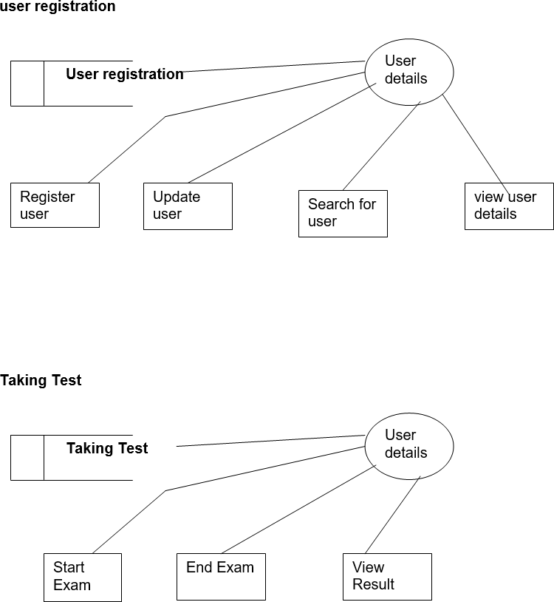

### Modules Used

1:ADMIN MODULE

* + 1. INSTRUCTOR MODULE
    2. STUDENT MODULE

#### ADMIN MODULE:

* 1. :REGISTER
  2. LOGIN
  3. CHANGE PASSWORD&FORGOTPASSWORD
  4. STUDENT -MODIFING DETAILS
  5. DEPARTMENTS-ENTERING/MODIFYING DETAILS
  6. INSTRUCTOR DETAILS-MODIFYING DETAILS

1. REGISTER:To be authenticated firest have to be registered.
2. LOGIN:The Registered User Can be Allowed to view inner details for which he Permitted
3. CHANGE PASSWORD&FORGOTPASSWORD:User has rights to modify his login details& also be informed through mails if he is unable to login.
4. STUDENT -MODIFING DETAILS:User can be modified to change status each User.
5. DEPARTMENTS-ENTERING/MODIFYING DETAILS:New departments adding and old departmentd deletions are spend by this user.
6. INSTRUCTOR DETAILS-MODIFYING DETAILS:According to staff he can add or delete Instructors for specific platforms.

#### INSTRUCTOR MODULE:

* 1. REGISTER
  2. LOGIN

3CHANGE PASSWORD&FORGOT PASSWORD

1. ADD QUESTIONS-DEPARTMENTS VERIFING.
2. UPDATE QUESTIONS -DEPARTMENTS VERIFING
3. CREATE EXAMS
4. UPDATE EXAMS
5. IEW EXAM DETAILS- VIEW NO OF REGISTERED STUDENTS

VIEW NO OF ATTENDED STUDENTS

1. EVALUATE QUESTION:MULTIPLE CHOICE

TUE/FALSE

1. REGISTER:To be authenticated firest have to be registered.
2. LOGIN:The Registered User Can be Allowed to view inner details for which he Permitted
3. CHANGE PASSWORD&FORGOTPASSWORD:User has rights to modify his loging details& also be informed through mails if he is unable to login
4. ADD QUESTIONS-DEPARTMENTS VERIFING:According to flow of questions & Technology he can add questions into the database.
5. UPDATE QUESTIONS -DEPARTMENTS VERIFING:If any corrections in data of questions he can modify them
6. CREATE EXAMS:He will be prepared schedule for exams periodically.
7. UPDATE EXAMS:He has rights to modify exam schedule.
8. IEW EXAM DETAILS- VIEW NO OF REGISTERED STUDENTS, VIEW NO OF

ATTENDED STUDENTS:Can view at attended students who has registered.

1. EVALUATE QUESTION:MULTIPLE CHOICE

TUE/FALSE:Evaluation of marks based on his initiations adding questions

#### STUDENT DETAILS:

* 1. REGISTER
  2. LOGIN
  3. TAKE EXAM- MULTIPLE CHOICE
  4. SEE EXAM RESULTS
  5. LOGOUT

1. REGISTER:To be authenticated firest have to be registered
2. LOGIN:The Registered User Can be allowed to view inner details for which Permitted
3. TAKE EXAM- MULTIPLE CHOICE, TRUE/FALSE:The registred student allowed to start the exam
4. SEE EXAM RESULTS:After Completion of exam he can view at his result.
5. LOGOUT:After the process of examination he turned to Logout page.

### Data Flow Diagram

A Data Flow Diagram (DFD) is a graphical representation of the "flow" of data through an information system, modeling its process aspects. A DFD is often used as a preliminary step to create an overview of the system, which can later be elaborated. DFDs can also be used for the visualization of data processing (structured design).

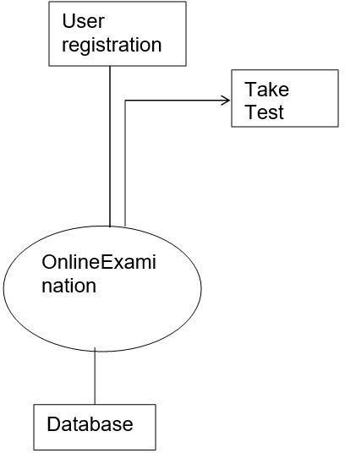

### Advantages

The package was designed to facilitate easy future modifications.

* Automation improves system efficiency.
* User-friendly interface enhances usability.
* Access control ensures appropriate permissions.
* Overcomes delays in communication.
* Information updating simplified.
* System security, data security, and reliability are key features.

### Requirement Specification

##### Hardware Requirements:

* + - * Pentium-IV Processor
      * 256 MB RAM
      * 512 KB Cache Memory
      * 10 GB Hard Disk
      * Microsoft Compatible Keyboard (101 keys or more)

##### Software Requirements:

* + - * Operating System: Windows
      * Web Technology: PHP
      * Front-End: HTML, CSS, JavaScript
      * Back-End: PHP, MySQL
      * Web Server: Apache Server

**CHAPTER 4**

**Implementation and Result**

**CHAPTER 4 IMPLEMENTATION and RESULT**

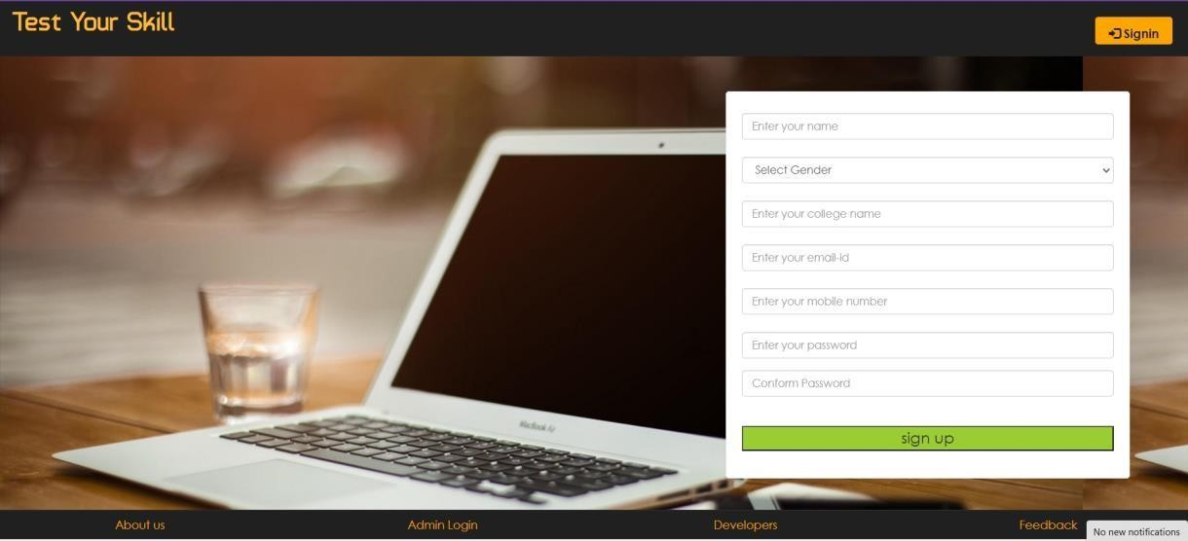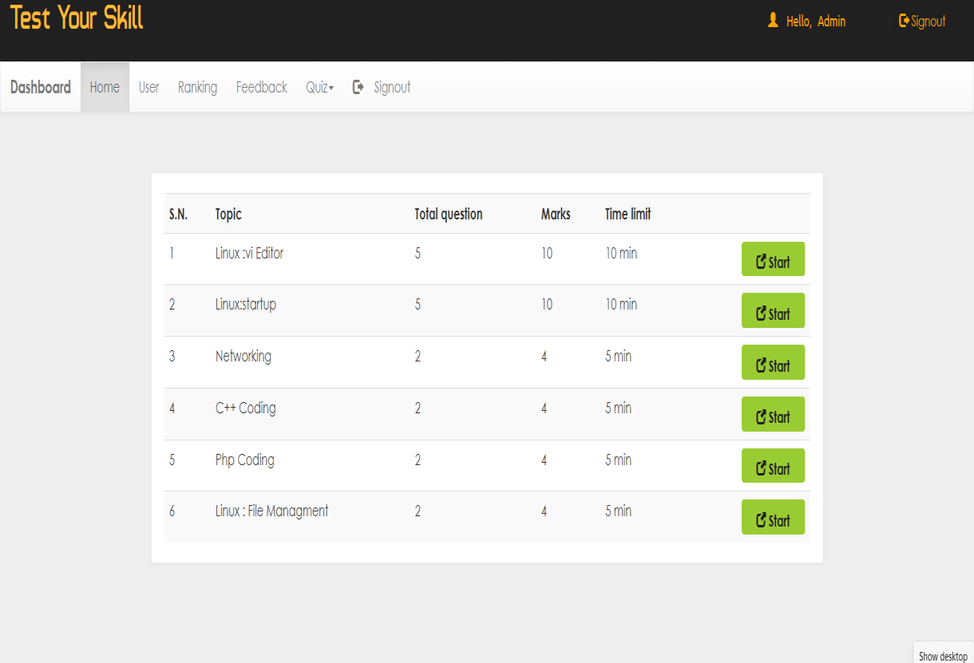

# CHAPTER 5 CONCLUSION

**CHAPTER 5 CONCLUSION**

### ADVANTAGES:

The package was designed to facilitate easy future modifications.

* Automation improves system efficiency.
* User-friendly interface enhances usability.
* Access control ensures appropriate permissions.
* Overcomes delays in communication.
* Information updating simplified.
* System security, data security, and reliability are key features.

### SCOPE:

This application avoids manual work and associated problems. Future Enhancements:

* + Enhanced User Experience
  + Advanced Reporting and Analytics
  + Integration with Learning Management Systems (LMS)
  + Mobile Compatibility
  + Enhanced Security Features
  + Intelligent Automation

The enhancement that we can add the searching option. We can directly search to the particular student details from this site.

# REFERENCES

* [https://www.researchgate.net/publication/317306939_Online_Examination_](https://www.researchgate.net/publication/317306939_Online_Examination_System) [System](https://www.researchgate.net/publication/317306939_Online_Examination_System)

# APPENDIX

* [**https://www.conductexam.com/blog/online-examination-system-main-**](https://www.conductexam.com/blog/online-examination-system-main-objectives-and-its-benefits)[**objectives-and-its-benefits**](https://www.conductexam.com/blog/online-examination-system-main-objectives-and-its-benefits)
* [**https://thinkexam.com/blog/introduction-online-examination-system-how-**](https://thinkexam.com/blog/introduction-online-examination-system-how-does-it-work-its-pros-cons/)[**does-it-work-its-pros-cons/**](https://thinkexam.com/blog/introduction-online-examination-system-how-does-it-work-its-pros-cons/)

# GITHUB LINK

* [**https://github.com/NAVAZ24/Online-Examination-System**](https://github.com/NAVAZ24/Online-Examination-System)